Development and Validation of a Silver-Coated Nanostructured Silicon SERS Sensor for Detection of N-Acetylmuramic Acid (NAM)
Abstract
Surface-Enhanced Raman Scattering (SERS) is a powerful analytical technique capable of detecting trace molecular species through electromagnetic enhancement generated by noble metal nanostructures. In this work, a nanostructured silicon-based SERS substrate was fabricated and evaluated for the detection of N-Acetylmuramic Acid (NAM), a key bacterial cell wall biomarker relevant to infection diagnostics.
The sensor consisted of a nanostructured silicon wafer coated with silver using an AgNO₃-based deposition process. Rhodamine 6G (R6G) was employed as a positive control to validate substrate enhancement performance, while NAM was used as the target analyte. Raman spectra were acquired using a 785 nm excitation laser under multiple experimental conditions including varying soaking times, laser powers, accumulation counts, and replicate measurements.
A complete data-processing pipeline was developed including spectral quality auditing, baseline correction, Savitzky-Golay smoothing, cosmic ray removal, peak detection, peak matching, reproducibility analysis, principal component analysis (PCA), and signal-to-noise ratio (SNR) evaluation.
The fabricated substrate successfully detected R6G with high peak matching accuracy (84.58%) and excellent wavelength calibration accuracy (RMSE = 3.67 cm⁻¹). NAM spectral features were detected; however, the observed mean SNR remained low (0.89), indicating insufficient enhancement for reliable biomarker detection. The results demonstrate that the fabricated sensor is functional and capable of SERS enhancement but requires further optimization of nanostructure morphology and silver nanoparticle density to achieve robust NAM sensing.

1. Introduction
Rapid identification of bacterial biomarkers is important for early diagnosis of infectious diseases. N-Acetylmuramic Acid (NAM) is a structural component of bacterial peptidoglycan and serves as a potential molecular marker for bacterial detection.
Surface-Enhanced Raman Scattering offers a promising route for label-free detection of bacterial biomarkers due to its high sensitivity and molecular specificity. The effectiveness of SERS depends strongly on the morphology of the substrate and the density of electromagnetic hotspots generated by metallic nanostructures.
The objective of this study was:
- Fabricate a silver-coated nanostructured silicon SERS substrate.
- Validate substrate performance using Rhodamine 6G.
- Evaluate the feasibility of detecting NAM.
- Identify sensor limitations and future optimization requirements.

2. Sensor Design and Fabrication
2.1 Technical Description
Substrate Material:
Silicon Wafer (Si)
Surface Modification:
Nanostructured / Etched Silicon Surface
Metal Coating:
Silver (Ag) deposited using an AgNO₃-based process
Detection Principle:
Surface-Enhanced Raman Scattering (SERS)
Excitation Source:
785 nm Raman Laser
Target Molecule:
N-Acetylmuramic Acid (NAM)
Positive Control:
Rhodamine 6G (R6G)

2.2 Fabrication Workflow
The silicon wafer surface was first nanostructured to increase surface roughness and available hotspot locations.
Following surface preparation, silver was deposited using an AgNO₃-based coating process to create plasmonic nanostructures capable of enhancing Raman scattering.
The fabricated substrates were subsequently exposed to analyte solutions and allowed to dry before Raman measurements.
Experimental variables investigated included:
- Soaking Time: 3, 4, 5, and 6 minutes
- Laser Power: 5% and 10%
- Accumulations: 3 and 5
- Multiple replicate measurements

3. Experimental Dataset
Total Spectra Acquired: 99
R6G Spectra: 48
NAM Spectra: 51
Raman Region Analyzed:
500–2000 cm⁻¹
Raw Spectral Length:
2048 points
Fingerprint Region Length:
1146 points

4. Data Processing and Validation Pipeline
A complete preprocessing and validation workflow was developed.
Stage 1 – Data Audit
All spectra were validated for:
- Missing values
- Duplicate Raman shifts
- File integrity
- Metadata extraction

Stage 2 – Baseline Correction
Asymmetric Least Squares (ALS) baseline correction was applied to remove fluorescence background.
Figure:
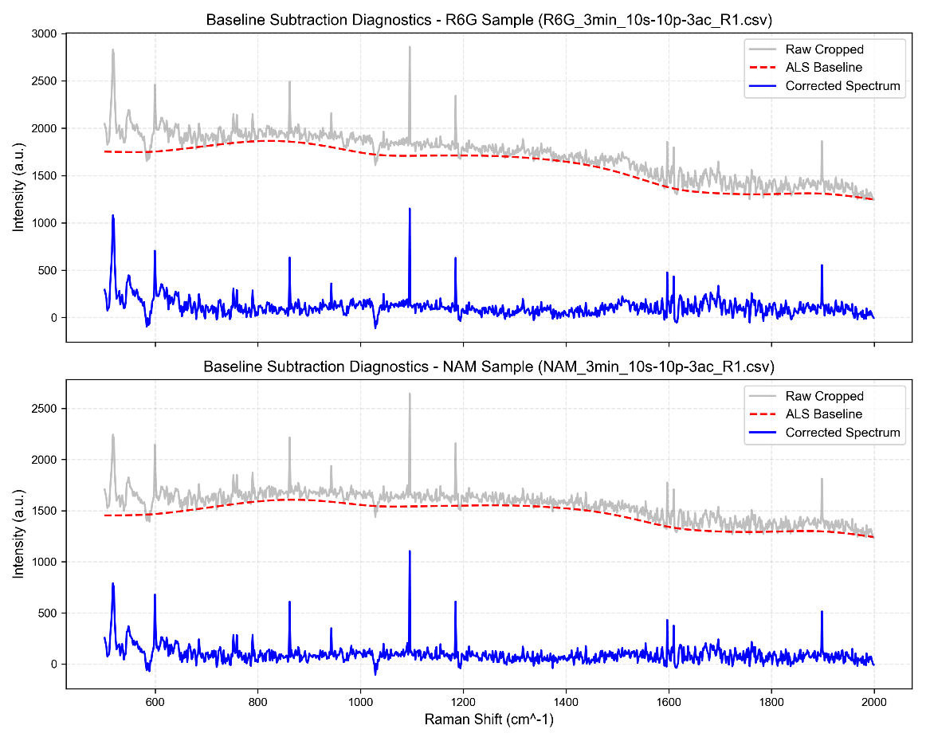
Result:
Effective removal of background drift while preserving Raman peaks.

Stage 3 – Spectral Smoothing
Savitzky-Golay filtering was applied.
Figure:
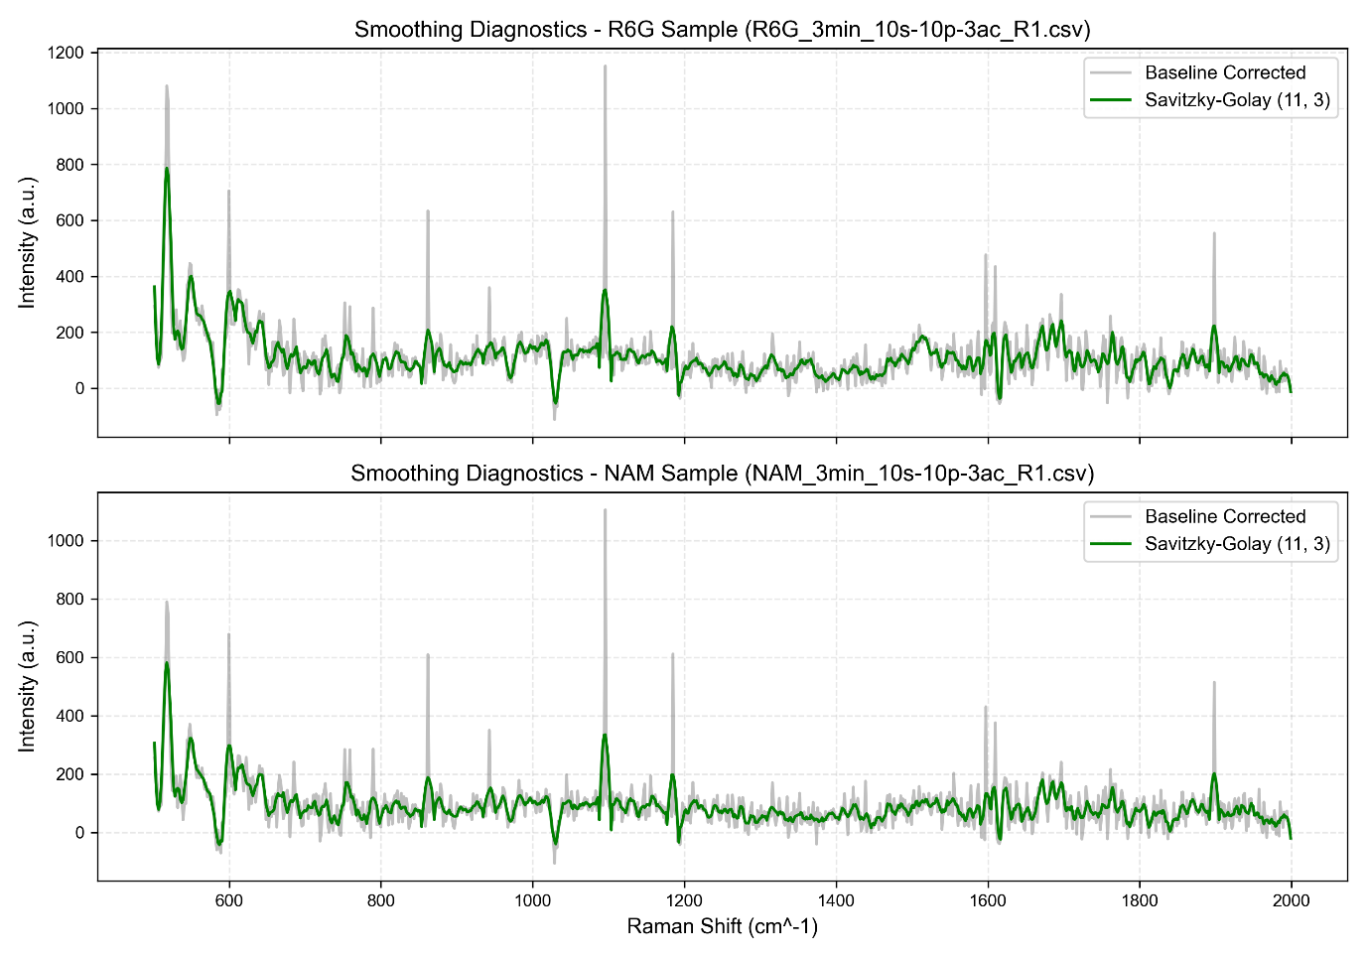
Result:
78.3% reduction in high-frequency noise.

Stage 4 – Cosmic Ray Removal
Single-pixel CCD spikes were detected and corrected using a modified z-score method.
Figure:
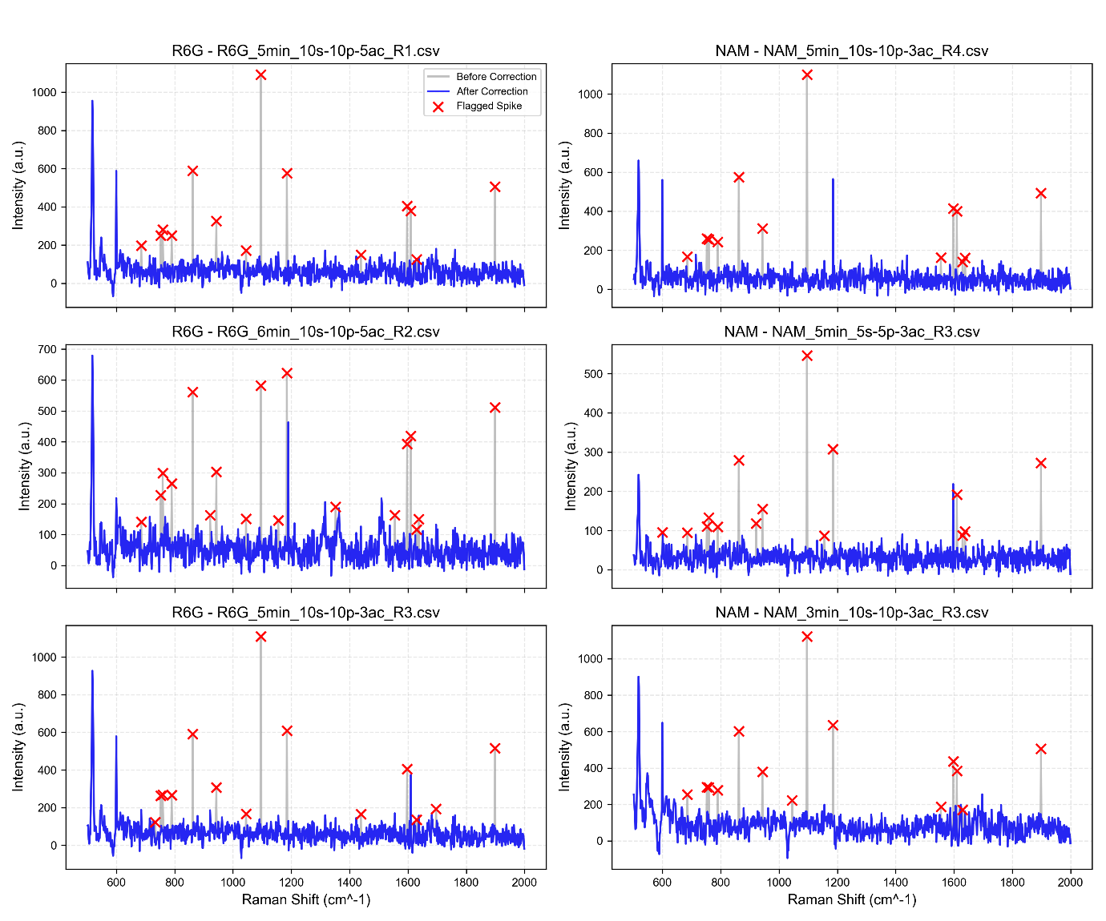
Results:
- Total spikes removed: 1491
- Mean spikes per spectrum: 15.06
- Signal retention: 99.72%
- Noise reduction: 33.57%
This confirmed that spike removal improved spectral quality without distorting real Raman features.

5. Positive Control Validation Using Rhodamine 6G
R6G was used to verify substrate enhancement performance.
Figure:
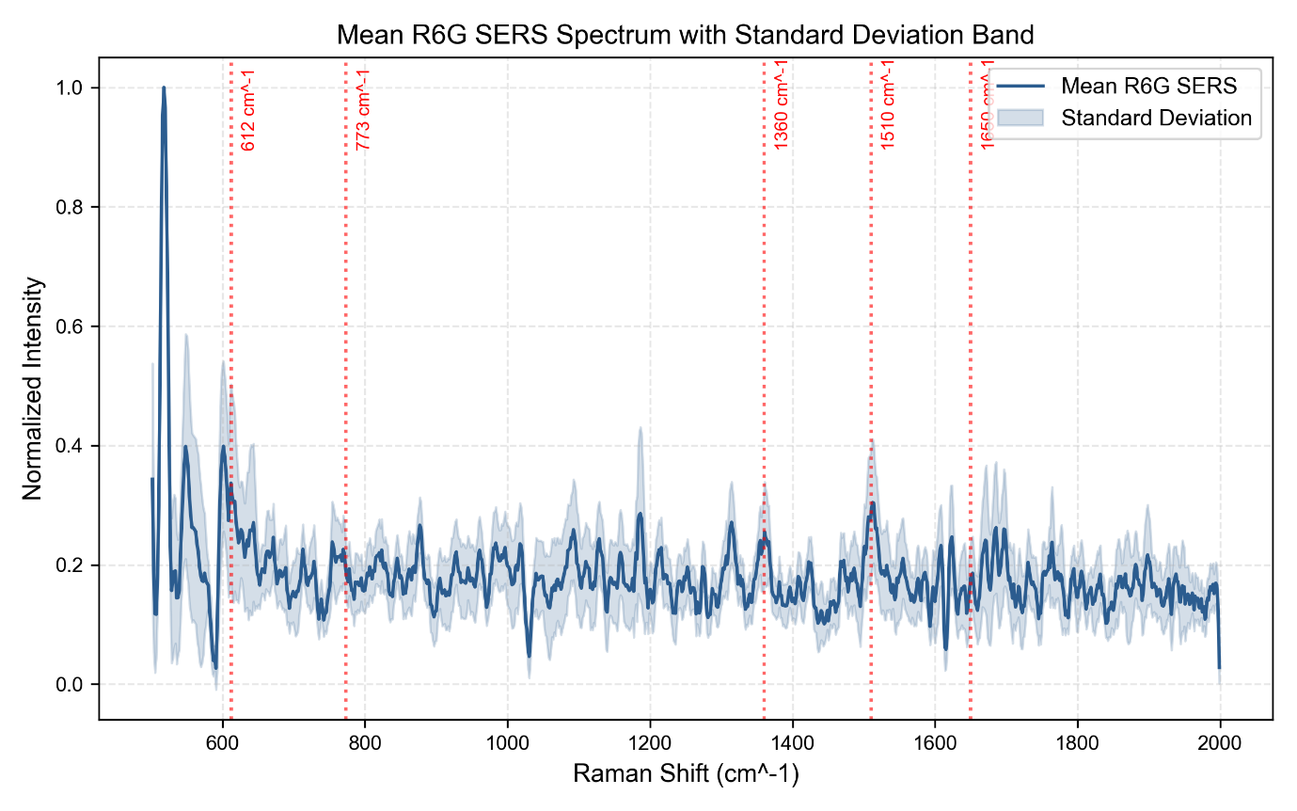
Peak Detection Performance
Optimized Parameters:
- Prominence = 0.01
- Width = 2
- Distance = 5
Key Literature Peaks:
- 612 cm⁻¹
- 773 cm⁻¹
- 1360 cm⁻¹
- 1510 cm⁻¹
- 1650 cm⁻¹
Results:
Peak Matching Accuracy:
84.58%
Mean Shift Error:
+0.81 cm⁻¹
MAE:
3.25 cm⁻¹
RMSE:
3.67 cm⁻¹
These results confirm accurate wavelength calibration and successful SERS enhancement.

6. Sensor Reproducibility Analysis
Peak Uniformity at 612 cm⁻¹:
- 5 min: 12.0%
- 4 min: 12.8%
- 6 min: 14.5%
- 3 min: 14.8%
Classification:
Good Uniformity
Mean Pearson Correlation:
0.7754
Best Correlation:
0.81
The substrate demonstrates reproducible enhancement but remains below the target correlation threshold of 0.90.

7. Sensor Optimization Study
Soaking Time Optimization
Readiness Scores:
6 min:
73.05
3 min:
67.96
4 min:
65.89
5 min:
64.06
Optimal Soaking Time:
6 Minutes

Laser Power Optimization
10% Laser Power:
- SNR = 3.56
- Detection Frequency = 85%
5% Laser Power:
- SNR = 2.44
- Detection Frequency = 68.3%
Optimal Power:
10%

Accumulation Optimization
5 Accumulations:
- Mean SNR = 3.70
3 Accumulations:
- Mean SNR = 2.30
Optimal Accumulations:
5

8. NAM Detection Analysis
Figure:
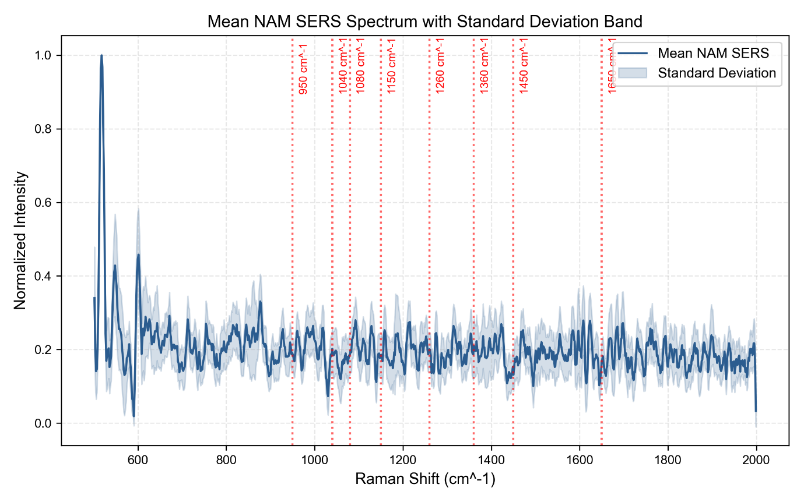
Reference NAM Peaks:
- 950 cm⁻¹
- 1040 cm⁻¹
- 1080 cm⁻¹
- 1150 cm⁻¹
- 1260 cm⁻¹
- 1360 cm⁻¹
- 1450 cm⁻¹
- 1650 cm⁻¹
NAM spectral signatures were successfully observed across multiple experimental conditions.
Optimal Parameters:
- Soaking Time: 5 minutes
- Laser Power: 10%
- Accumulations: 5
9. Comparative Performance Analysis
Comparison of R6G and NAM Performance:
R6G:
- Mean SNR = 3.00
- High detection reliability
- Strong Raman enhancement
NAM:
- Mean SNR = 0.89
- Peaks detectable
- Low enhancement
This indicates that the substrate is capable of detecting NAM but does not currently provide sufficient enhancement for robust biological sensing.
10. Scientific Conclusions
The fabricated silver-coated nanostructured silicon substrate successfully generated measurable SERS enhancement.
Key achievements include:
- Successful fabrication of nanostructured silicon SERS substrates.
- Accurate Raman shift calibration (RMSE = 3.67 cm⁻¹).
- Reliable detection of Rhodamine 6G.
- Successful implementation of a complete SERS preprocessing and validation pipeline.
- Detection of NAM spectral signatures.
However, the enhancement generated by the current substrate is insufficient for strong detection of weak Raman-scattering biomolecules such as NAM.
Final Sensor Status:
NAM DETECTABLE BUT REQUIRES OPTIMIZATION
11. Future Work
To improve NAM detection performance, the following modifications are recommended:
- Increase silver nanoparticle density on the silicon surface.
- Investigate multiple Ag deposition cycles.
- Optimize nanostructure geometry for higher hotspot density.
- Evaluate Ag-Au hybrid coatings.
- Study lower-volume analyte deposition strategies.
- Perform concentration-dependent NAM studies.
- Evaluate additional bacterial biomarkers including LPS and LTA fragments.
The validated fabrication and analysis workflow developed in this study provides a strong foundation for future development of SERS-based bacterial biomarker sensors.

